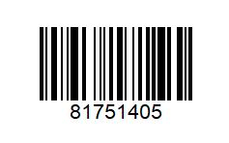 | 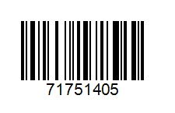
EV Meal Fries & Drink €4 | EV Meal Fries & Drink €4 (code change)
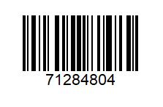 | 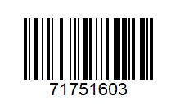
EV Meal & Happy Meal €9.50 | EV Meal & Cheeseburger €7.50
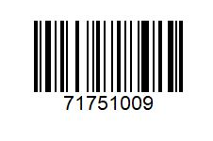 | 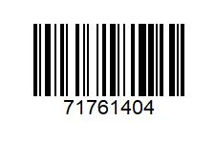
EV Meal & McFlurry €7.50 | EV Meal & Nuggets €7.50
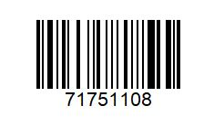 | 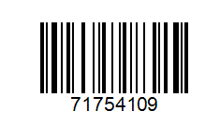
EV Meal & Mayo Chicken €7.50 | EV Meal & Halloumi Fries €7
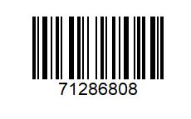 | 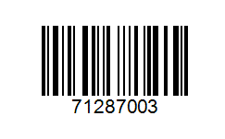
2 Extra Valu Meals €12 | 2 Extra Valu Meals €13
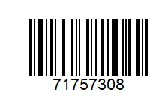 | 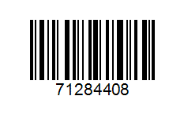
2 EV Meals & 2 Happy meals €16 | 2 EV Meals & 2 Happy meals €19
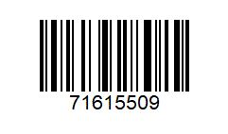 | 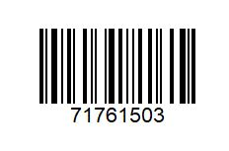
Fillet O Fish €5 | Veg Delux Meal & Apple Pie €7.50
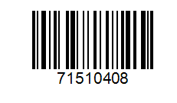
Free Coffee w/Happy Meal
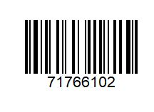 | 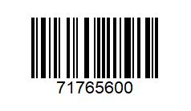
Big Mac or ¼ Pounder & Fries Only €4.20 | McChicken & Fries €3.90
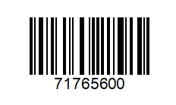 | 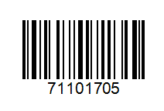
McChicken w/cheese & Fries €4.20 | Cheese Burger & Chips €2.00
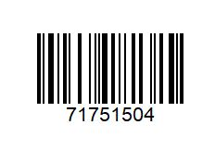 | 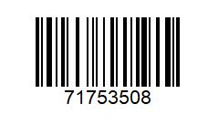
€3 Sandwich & Fries | Veg Delux. / Veg Dipper Fries €4.20
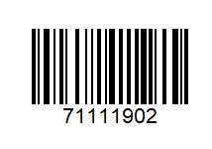 | 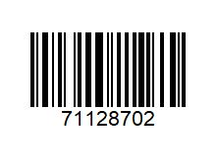
Big Mac €2.50 | Grand Big Mac / Italian / Spicy Spanish Stack €4
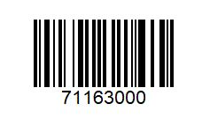 | 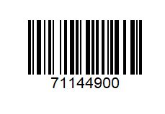
¼ Pounder | McChicken Sambo €2
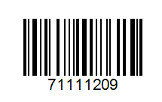 | 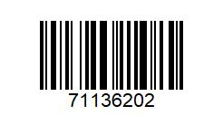
McChicken Sambo €2.50 | Chicken Legend €3
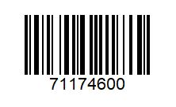 | 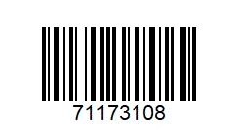
Veg Delux €2 | €2 McPlant
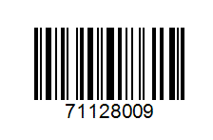 | 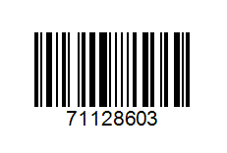
Seasonal Promo Burger €5 | Seasonal Promo €4
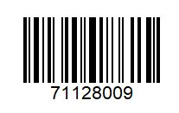
BBQ Bacon Stack €5
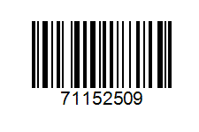 | 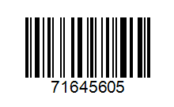
9 Nuggets €2 | 9 Nuggets €2.50
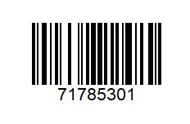 | 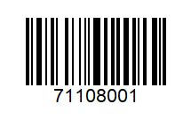
6 Nuggets €2 | 3 Chicken Select €3
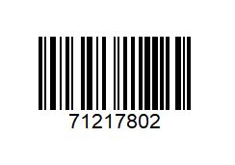 | 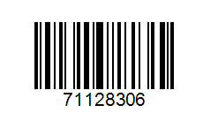
4 Veg Dippers €2 | Chicken Big Mac €5

