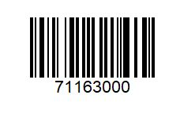 | 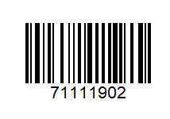
¼ Pounder | Big Mac €2
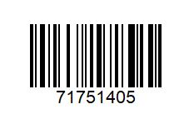 | 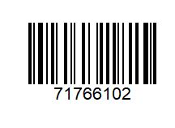
EV Meal €4 | Big Mac or ¼ Pounder & Fries Only €4.20
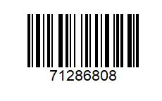 | 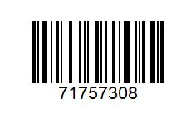
2 Extra Value Meals €12 | 2 EV Meals & 2 Happy meals €18
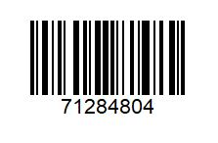 | 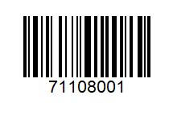
EV Meal & Happy Meal €8 | 3 Chicken Select €3
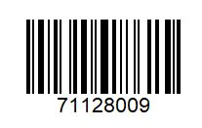 | 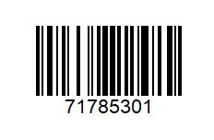
BBQ Bacon Stack €5 | 6 Nuggets €2
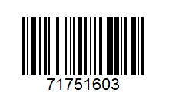 | 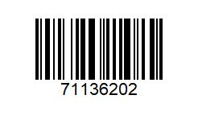
EV Meal & Cheeseburger €7.50 | Chicken Legend €3
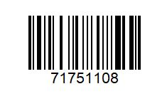
EV Meal & Mayo Chicken €7.50
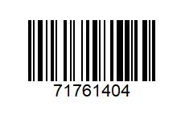 | 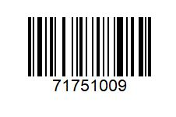
EV Meal & Nuggets €7.50 | EV Meal & McFlurry €7.50
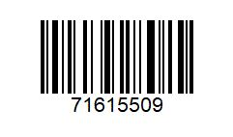 | 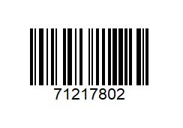
Fillet O Fish €5 | 4 Veg Dippers €2
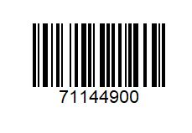 | 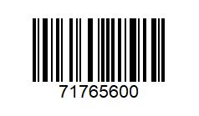
McChicken Sambo €2 | McChicken & Fries €3.90
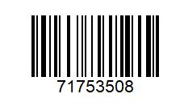 | 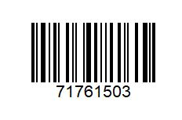
Veg Delux. / Veg Dipper Fries €3.90 | Veg Delux Meal & Apple Pie
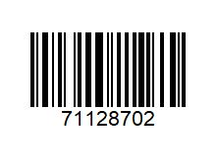 | 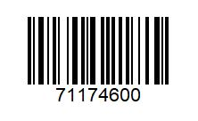
Grand Big Mac €4 | Veg Delux €2

