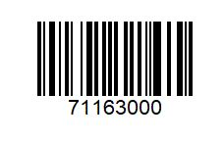 | ¼ Pounder
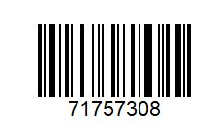 | 2 EV Meals & 2 Happy meals €18
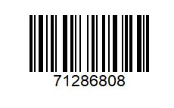 | 2 Extra Value Meals €12
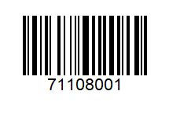 | 3 Chicken Select €3
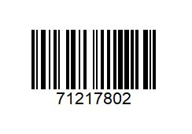 | 4 Veg Dippers €2
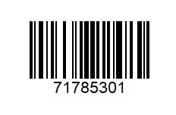 | 6 Nuggets €2
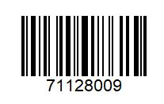 | BBQ Bacon Stack €5
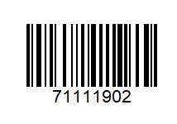 | Big Mac €2
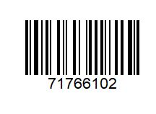 | Big Mac or ¼ Pounder & Fries Only €4.20
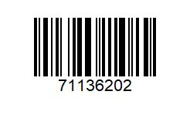 | Chicken Legend €3
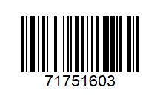 | EV Meal & Cheeseburger €7.50
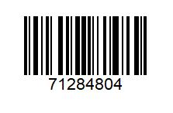 | EV Meal & Happy Meal €8
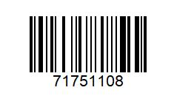 | EV Meal & Mayo Chicken €7.50
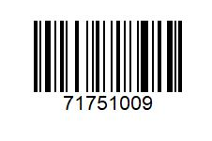 | EV Meal & McFlurry €7.50
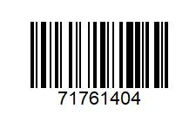 | EV Meal & Nuggets €7.50
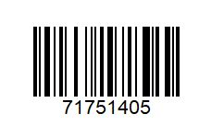 | EV Meal €4
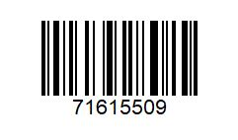 | Fillet O Fish €5
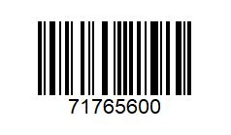 | McChicken & Fries €3.90
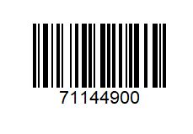 | McChicken Sambo €2
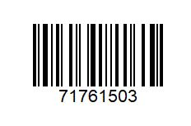 | Veg Delux Meal & Apple Pie
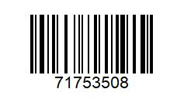 | Veg Delux. / Veg Dipper Fries €3.90
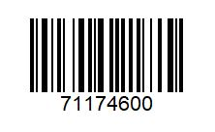 | Veg Delux €2
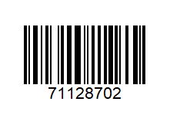 | Grand Big Mac €4

