Group name | grpMain
Other info | 15 group items, mainly because I create the ‘Save icon’ using individual shapes!  The first group item is shown by the red border; each of the tabs is next in groupitem sequence; the Save button is next and then there are 7 shapes combined to make the ‘Save icon’. I have code for the ‘Save icon’ if anyone wants it.  The ‘reset button consists of two shapes.

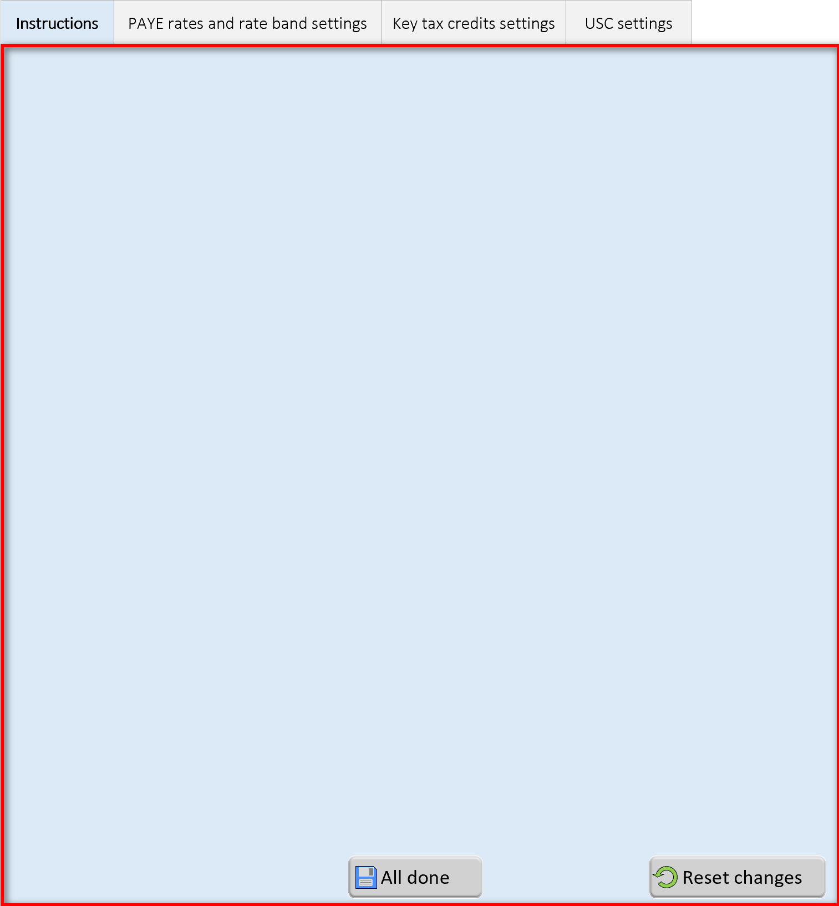

Group name | grpInstructions
Other info | 2 group items- black border is groupitem1

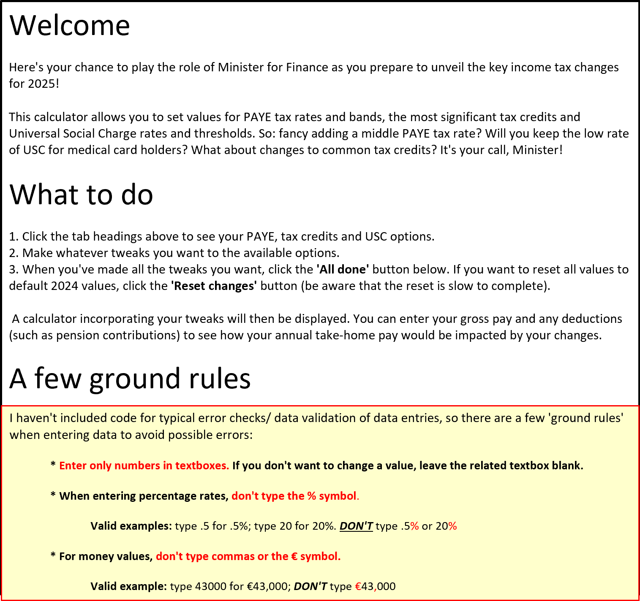

Group name | grpPAYE
Other info | 33 group items; count groupitems starting on top row (left hand side), moving right, down to next row etc. The toggle switch at top right (another homemade effort!) consists of 6 individual shapes.

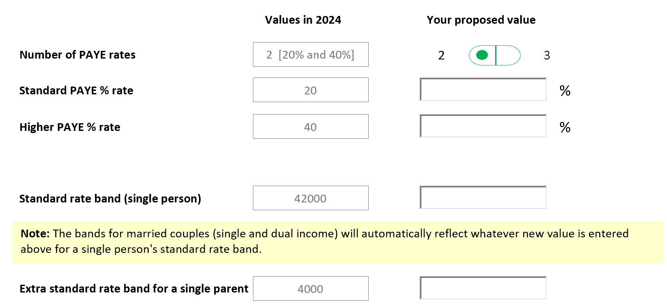
Image 1: grpPAYE showing 2 tax rates
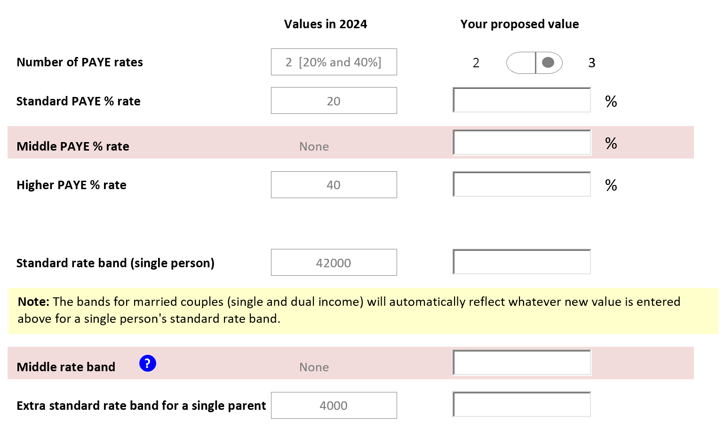
Image 2: grpPAYE showing 3 tax rates

Group name | grpUSC
Other info | 28 group items; as above, count groupitems starting on top row, moving right, down to next row etc.

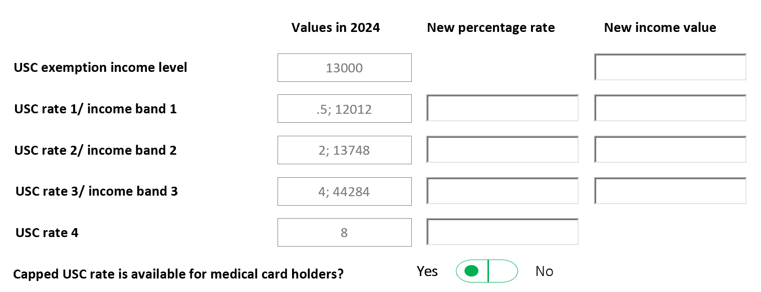

The code that runs when a tab is clicked:
Sub ShowTab()
Dim grpTabContent As ShapeRange
Set grpTabContent = Sheet6.Shapes.Range(Array("grpInstructions", "grpPAYE", "grpUSC", "grpTaxCredits")) ‘the 4 content units as shown above

grpTabContent.Visible = msoFalse ‘make all content units invisible
grpTabContent.Item(Sheet6.Shapes(Application.Caller).AlternativeText).Visible = True ‘show the content unit whose group name matches the ‘AlternativeText’ property of the clicked tab (each tab has the relevant name stored as its Alternative text)
‘Special code for the grpPAYE- basically decides whether to show layout for 2 or 3 tax rates based on a cell (named range= blnTwoTaxRates ) which is toggled TRUE/ FALSE by the toggle switch
If Sheet6.Shapes(Application.Caller).AlternativeText = "grpPAYE" Then
Sheet6.Shapes.Range(Array("Rectangle 14", "Rectangle 562175", "TextBox2", "Rectangle 23")).Visible = Not Sheet6.Range("blnTwoTaxRates")
Sheet6.Shapes.Range(Array("Rectangle 26", "Oval 562196", "Rectangle 562183","TextBox5")).Visible = Not Sheet6.Range("blnTwoTaxRates")
End If
Call FormatTabHeaderAndHeight ’ code shown below; basically adjusts the height of the grpMain first group item and repositions the 2 buttons plus related icons
End Sub

Sub FormatTabHeaderAndHeight()

Dim grpTabHeaders As ShapeRange
Dim i As Integer
Dim strSaveTopAdjs As String, arrSaveTopAdjs() As String
‘these are top adjustments for the save icon- each individual shape needs to be repositioned
strSaveTopAdjs = "6.7501,7.5002,15.3756,8.2503,18.7509,17.6258,16.1256"
arrSaveTopAdjs = Split(strSaveTopAdjs, ",")

Set grpTabHeaders = Sheet6.Shapes.Range(Array(Sheet6.Shapes("grpMain").GroupItems(2).Name, Sheet6.Shapes("grpMain").GroupItems(3).Name, Sheet6.Shapes("grpMain").GroupItems(4).Name, Sheet6.Shapes("grpMain").GroupItems(5).Name))

'Show tab headers as selected/deselected
For i = 1 To grpTabHeaders.count
With grpTabHeaders.Item(i)
.Fill.ForeColor.RGB = Switch(.Name = Application.Caller, 16247516, Not .Name = Application.Caller, 15921906) 'light grey
.TextFrame.Characters.Font.Bold = Switch(.Name = Application.Caller, True, Not .Name = Application.Caller, False)
End With
Next i

‘Adjust the height of the shape depending on which tab is currently showing
Select Case Application.Caller ‘identifies the clicked tab name
Case Sheet6.Shapes("grpMain").GroupItems(2).Name 'clicked the Instructions tab
With Sheet6.Shapes("grpMain")
.GroupItems(1).Height = 581
.GroupItems(6).Top = .GroupItems(1).Top + .GroupItems(1).Height - Sheet6.Shapes("grpMain").GroupItems(6).Height - 5
‘adjusting the Save icon top position
For i = 1 To 7
.GroupItems(i + 6).Top = .GroupItems(6).Top + arrSaveTopAdjs(i - 1)
Next i
‘Adjusting the reset button top position
.GroupItems(14).Top = .GroupItems(6).Top
‘Adjusting the circular icon top position to the middle of the reset button
.GroupItems("imgReset").Top = .GroupItems(14).Top + (0.5 * (.GroupItems(14).Height - .GroupItems("imgReset").Height))
End With
‘Same basic idea repeated for other content
Case Sheet6.Shapes("grpMain").GroupItems(3).Name 'clicked the PAYE tab
With Sheet6.Shapes("grpMain")
.GroupItems(1).Height = Switch(Not Sheet6.Range("blnTwoTaxRates").Value, 403, Sheet6.Range("blnTwoTaxRates").Value, 320)
.GroupItems(6).Top = .GroupItems(1).Top + .GroupItems(1).Height - Sheet6.Shapes("grpMain").GroupItems(6).Height - 5
For i = 1 To 7
.GroupItems(i + 6).Top = .GroupItems(6).Top + arrSaveTopAdjs(i - 1)
Next i
.GroupItems(14).Top = .GroupItems(6).Top
.GroupItems("imgReset").Top = .GroupItems(14).Top + (0.5 * (.GroupItems(14).Height - .GroupItems("imgReset").Height))
End With
Case Sheet6.Shapes("grpMain").GroupItems(4).Name 'clicked the USC tab
With Sheet6.Shapes("grpMain")
.GroupItems(1).Height = 280
.GroupItems(6).Top = .GroupItems(1).Top + .GroupItems(1).Height - Sheet6.Shapes("grpMain").GroupItems(6).Height - 5
For i = 1 To 7
.GroupItems(i + 6).Top = .GroupItems(6).Top + arrSaveTopAdjs(i - 1)
Next i

.GroupItems(14).Top = .GroupItems(6).Top
.GroupItems("imgReset").Top = .GroupItems(14).Top + (0.5 * (.GroupItems(14).Height - .GroupItems("imgReset").Height))

End With

Case Sheet6.Shapes("grpMain").GroupItems(5).Name 'clicked the tax credits tab

With Sheet6.Shapes("grpMain")
.GroupItems(1).Height = 380
.GroupItems(6).Top = .GroupItems(1).Top + .GroupItems(1).Height - Sheet6.Shapes("grpMain").GroupItems(6).Height - 5
For i = 1 To 7
.GroupItems(i + 6).Top = .GroupItems(6).Top + arrSaveTopAdjs(i - 1)
Next i
.GroupItems(14).Top = .GroupItems(6).Top
.GroupItems("imgReset").Top = .GroupItems(14).Top + (0.5 * (.GroupItems(14).Height - .GroupItems("imgReset").Height))
End With
End Select
End Sub

