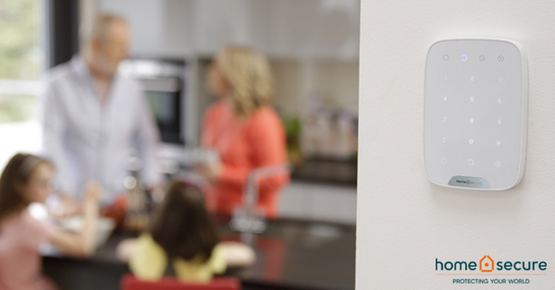

HomeSecure Renewal
Hi <<First Name>>,
Thank you for being a loyal HomeSecure customer, we trust you and your family feel safe in the knowledge that your home is connected to our 24hour monitoring station open 365 days of the year.
Please be aware that your current contract will expire on <<ENDDATE>>. As a loyal customer we have great news, by renewing your contract we will freeze your monthly monitoring fee at the same great price for the year to come.

Call Now

Introducing Our Charity Partner LauraLynn
We would love to inform you about our wonderful charity partner, LauraLynn, Ireland’s only Children’s Hospice. LauraLynn provides special palliative care to children with life-limiting conditions and offers support to their families.
So far, with the support of our customers, we will donate over €60,000 this year. You can join our support by adding just €1 to your monthly fee, which is then given to Laura Lynn.
100% of all donations are received by the hospice.

Learn More

What do you need to do?
- To continue to protect your home, with 24/7 instance response monitoring for another 12 months, simply ignore this email
- If you would like to contact us to donate €1 per month to LauraLynn please call 01-9203824

